Peter de Volder Paintings

2023

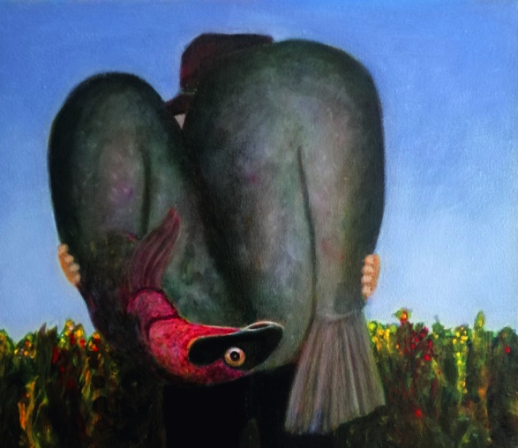

Big Fish 30x35 cm.
I searched the internet for images of fish, but mainly found rough men with a proud look above their just caught prey: big fish. Also a good movie by the way.

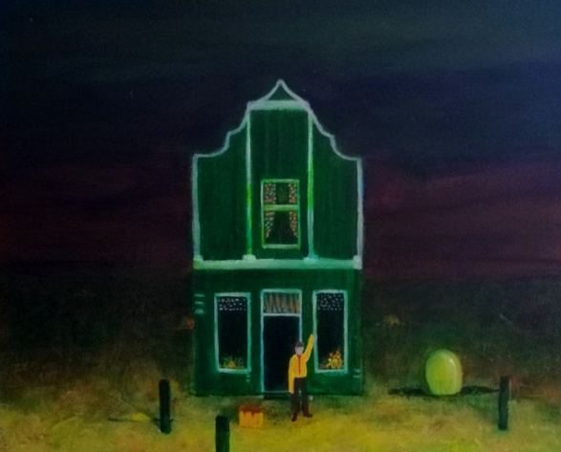
Bye Bye, 24x30 cm.
A man waves someone goodbye in front of the Zaanse house. next to him a suitcase. which has been left behind. Or he will leave himself, in a moment. An egg hatches from the ground. in different places. Birth.

2022

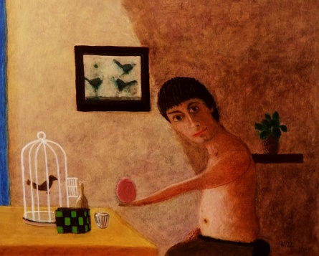

2022 The Egg. 24x30cm.

The man offers an egg, loose on his hand, and looks at us as if we still have to give approval. A birdcage with bars only at the front, the door open, a rather abstract painting of birds. I was happy with the skin. Painting skin is figuring out how light and how dark, how warm or colder. That can be done in so many ways.

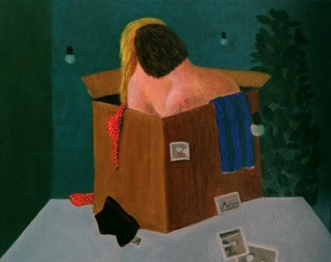

2022 On the table 24x30cm

On the table. The title says enough. A loving couple in a cardboard box, on the table. Their own world. The photos tell their own story, 3 light bulbs from the ceiling close by and further away. A green plant.

Happy with the people who suddenly appear in my work and I think: wow, I missed this, this is it!

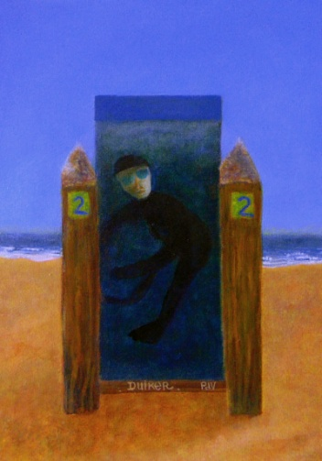

2022 Driver by the sea. 35x25 cm.

realism / surrealism. Diver by the sea, so not in the sea. In a cabinet of water, or a larger cabinet. Well no, more of a tight space. Nevertheless, she looks happy. It's a she. For me. Of course it is not possible, and it does not fit, in the water the diver, and that cupboard within the painting is also very small. The sea is infinite. The beach by the way.

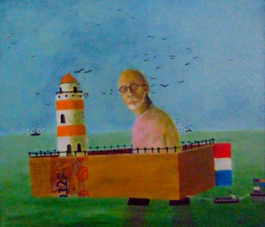

2022 Self-portrait at the Sea. 35x40 cm.
In a cardboard box with a lighthouse and fencing. I draw 2 ships. It's like a childhood fantasy, or a peaceful dream. A work of art that I know, by Pieter Engels, is called: The sea, The sea always moves me. The idea also has something to do with that, but our implementation is completely different. Painting is also my subject. How do I paint fabric, cardboard, a face, the sea water. North Sea. Dutch realism.

